Identity Property for a column.

Identity is used to generate auto numbers.
It is used to generate unique numbers.

Syntax --Identity(Seed, Increment)

Seed is the starting value
Increment is the step value (Can be negative)

Example –

Create table employees1
(EmpId int Identity(1,1),
EmpName Varchar(30));

Insert into employees1(EmpName) values('John');

Select * from employees1;

Seed and increment values should be only of INTEGER data type.
Only one identity column per table is allowed.

Set Identity_Insert tablename ON clause

Allows explicit values to be inserted into the identity column of a table.

create table X(y integer identity, z char);

Insert into X(z) Values('A');
Insert into X(z) Values('B');

select * from X;

Insert into X(y,z) Values(8,'C');

SET IDENTITY_INSERT X ON

Insert into X(y,z) Values(8,'C')

It is must to mention the column list after the table name

SET IDENTITY_INSERT X OFF

Insert into X(z) Values('C');
SELECT * FROM x; -- Y HAS GOT 9 VALUE

To see the last identity value use IDENT_Current built-in:

SELECT IDENT_Current ('X');

Identity and Delete Bevaiour
Deleting records will have no effect on the identity property. The next sequence number which was before the delete gets added for the new record.

create table ti1(a int identity, b int);
Insert Into ti1(b) Values(101);
Insert Into ti1(b) Values(102);
Insert Into ti1(b) Values(103);
select * from ti1;
Delete from ti1 where a > 1; -- Two records of a column's 2 and 3 records deleted
select * from ti1;
Insert Into ti1(b) Values(110);
select * from ti1; -- The a column gets 4 value not 2 !!

Drop Table ti1;

Resetting the Identity Value:

The identity value gets reset in the following two cases:
- When the table gets truncated
- By using the CheckIdent switch of the DBCC command.

- Demo of Truncating Table:

Drop Table Identity_Reset
go
Create Table Identity_Reset
(A int Identity,
B int)
go
Insert Into Identity_Reset(B) Values(101)
Insert Into Identity_Reset(B) Values(102)
Insert Into Identity_Reset(B) Values(103)
go
Select * from Identity_Reset
go
Truncate Table Identity_Reset
go
Insert Into Identity_Reset(B) Values(101) -- Identity Resets with 1
go
Select * from Identity_Reset
go

- Demo of CheckIdent switch of DBCC command

Syntax:

DBCC CHECKIDENT
(
table_name
[ , { NORESEED | { RESEED [ , new_reseed_value ] } } ]
)
[ WITH NO_INFOMSGS ]

NORESEED
Specifies that the current identity value should not be changed.
RESEED
Specifies that the current identity value should be changed.
new_reseed_value
Is the new value to use as the current value of the identity column.
WITH NO_INFOMSGS
Suppresses all informational messages.

DBCC CheckIdent(Identity_Reset, ReSEED, 0) -- 0 is considered as current value
Go

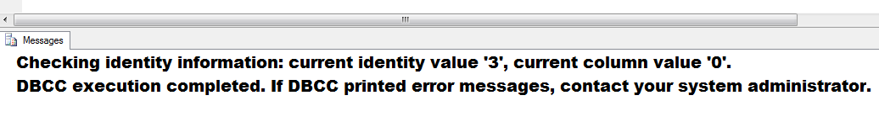
Insert Into Identity_Reset(B) Values(101)
go
Select * from Identity_Reset
Go

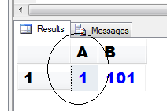

The CheckIdent switch can be used without deleting the records as well.

Insert Into Identity_Reset(B) Values(102) -- 2
Insert Into Identity_Reset(B) Values(103) -- 3
go

Select * from Identity_Reset
go

DBCC CheckIdent(Identity_Reset, ReSEED, 7) -- Mid way current value getting changed to 7
go

Insert Into Identity_Reset(B) Values(104)
go

Select * from Identity_Reset
Go

